CHECKLIST FOR MS SYNOPSIS/THESIS TOPIC APPROVAL DOCUMENT
DEPARTMENT OF CREATIVE TECHNOLOGIES (AIR UNIVERSITY)

Sr. No. | Content | Yes/ No
1 | Title Page | yes
2 | Table of Contents | yes
3 | Introduction | yes
4 | Problem Statement | yes
5 | Research Questions | yes
6 | Statement of Objectives | yes
7 | Literature Review | yes
7 | Proposed Methodology of Research | yes
 | - Protocol for Data Collection  - Experimental Setup  - Method of Analysis and Validation | yes
8 | Expected Results | yes
9 | Thesis Timeline | yes
10 | References | yes
11 | Curriculum Vitae of MS Scholar | yes
12 | Undertaking | yes
It is certified that the MS Synopsis/Thesis Topic Approval Report is according to the items listed in the above Check Sheet.
MS Scholar | Supervisor
Name: Taimoor Sarwar | Name: Dr. Azhar Imran Mudassir
Signature: | Signature:
Date: 02/01/2025 | Date: 02/01/2025

Anomaly Detection through Reinforcement Learning in Closed Loop Systems


By
Taimoor Sarwar (232806)
Master of Science in Artificial Intelligence

SUPERVISOR
Dr. Azhar Imran Mudassir
Assistant Professor

DEPARTMENT OF CREATIVE TECHNOLOGIES,
FACULTY OF COMPUTING AND ARTIFICIAL INTELLIGENCE,
AIR UNIVERSITY
ISLAMABAD

December 2024

Executive Summary

There is a growing recognition that future cyber defense should involve extensive use of partially autonomous agents that actively monitor the friendly network, detect and react to anomalous activities before the hostile malware or an attack inflict major damage, evade a closed loop system or destroy an air-gapped network. This requires cyber defense agents with a significant degree of intelligence, autonomy, self-learning and adaptability through Reinforcement Learning. In the context of anomaly detection often referred as outlier detection, the process of identifying unusual data points that significantly deviate from expected norms within a dataset. As industries continue to evolve and generate increasingly complex data, the need for robust and adaptable anomaly detection systems evolves day by day. By addressing these challenges and harnessing the power of machine learning, the organizations can enhance their ability to identify, analyze and respond to an unusual attack, ultimately improving decision-making and reliability of their systems. In this research, our approach is to develop such a RL based agent which initially trains itself from traditional statistical methods and deep dive into more advanced approaches through analyzing and identifying anomalies in real-time flow of data, thus improving accuracy and security driven by the power of Machine Learning (ML) while employing sophisticated detection algorithms by calculating cumulated rewards.
Table of Contents
Executive Summary 1
1. Introduction 1
2. Problem Statement 2
3. Research Questions 2
4. Statement of Objectives 2
5. Literature Review 3
6. Proposed Methodology of Research 6
6.1. Protocol for Data Collection 7
6.2. Experimental Setup 7
6.3. Method of Analysis and Validation 8
7. Expected Results 9
8. Thesis Timeline 10
9. References 11
Curriculum Vitae of MS Scholar 11
Undertaking 12

Introduction
Anomaly detection refers to the problem of finding patterns in data that do not conform to expected behavior. These non-conforming patterns are often referred to as anomalies, outliers, discordant observations, exceptions, aberrations, surprises, peculiarities or contaminants in different application domains. Of these, anomalies and outliers are two terms used most commonly in the context of anomaly detection; sometimes interchangeably. Anomaly detection finds extensive use in a wide variety of applications such as fraud detection for credit cards, insurance or health care, intrusion detection for cyber-security, fault detection in safety critical systems, and military surveillance for enemy activities. [1]
In the case of cyber security incidents, the implementation and application of response actions require signiﬁcant efforts from operators and developers in translating policies. To overcome those issues, we propose an automated closed-loop process with three stages. The ﬁrst stage focuses on obtaining the Decision Trees (DT) that classify anomalies. In the second stage, DTs are translated into security Policies as Code based on languages recognized by the Policy Engine (PE). In the last stage, the translated security policies feed the Policy Engines that enforce them by converting them into speciﬁc instruction sets. The adoption of a closed-loop helps reducing the security risks arising from organizations with outdated security rules. The continuous workﬂow keeps deployed rules updated, by taking into account the most recent monitoring data to adjust the notion of anomaly, and to automatically adjust deployed rules based on the retrained ML models generated in this way. [2]

Problem Statement
Our aim is to design Reinforcement Learning (RL) based agent with techniques to enhance anomaly detection through human-computer interaction, where human expert feedback on the agent's action serves as a critical reward mechanism for model convergence and improved decision-making. The challenge is to develop a closed-loop anomaly detection system using a Policy Engine (PE), which may be an Intrusion Detection & Prevention System (IDS/IPS) that learns iterative patterns from input and output signals. The purpose is to integrate these components to create an effective and adaptive anomaly detection framework. The system shall be capable of identifying deviations from normal data patterns as anomalies and classifying them with negative rewards. As the agent gets trained with real-time data processes, it would take appropriate action for making an accurate decision.

Research Questions
- How can anomaly detection algorithms be optimized for intrusion detection in air-gapped or industrial systems operating in closed-loop network?
- What are the most effective machine learning approaches for deploying, monitoring and assessing security policies in evolving cyber-security threat landscapes?
- How can reinforcement learning enhance the performance of anomaly detection systems in closed-loop network environment?

Statement of Objectives
Following objectives are intended to achieve through this research:
- To create and test algorithms specifically designed for detecting anomalies in closed-loop network environment, focusing on air-gapped and industrial systems.
- To explore and apply cutting-edge machine learning approaches that can effectively adapt to and mitigate evolving cyber-security threats.
- To integrate reinforcement learning into anomaly detection systems to improve their decision-making capabilities and overall performance in closed-loop network.

Literature Review
The proactive goal lists behaviors that help an agent improve its performance or its protection capability. To achieve the proactive goal, the agent should not simply act in response to its environment; it should be able to exhibit opportunistic, goal directed behavior and take initiatives when appropriate. Internally, the agent needs to evaluate itself frequently and apply updates (patches) when necessary. The agent also needs to assess the state of a system, understand what is normal, and have methods of detecting and characterizing anomalies, including analysis of all event logs. Toward detecting anomalies, the agent needs change-detection tools to discover unauthorized modifications to the file system, network device configuration, or application code [1]. It is evident that the evolving threat landscape requires the introduction of new approaches for deployment, monitoring and assessment of security policies. First part is to extract the Decision Trees (DTs) from Machine Learning (ML) models to identify the anomalies. Second part is to translate them into policies. Third part is to enforce them along with the different system components [2].
“Stuxnet” is referred to a malicious computer worm that specifically attacks Programmable Logical Controllers in an industrial or closed-loop system. When infected, it is able to reprogram the PLC and propagates in the air-gapped network. This was the case with in the attack on Iran’s nuclear program, where “Stuxnet” was used to do damage to the fast-spinning centrifuges to tear themselves apart and initial introduction to the target network was done with the use of an infected USB stick. Another example was Ukraine Power Grid attack in which Ukrainian energy companies were deteriorated and left 230,000 people without power for up to 6 hours. The initial intrusion into the targeted network was done with the use of stolen credentials received by phishing emails. Hackers then took over the SCADA network by accessing the Human Management Interface (HMI) systems remotely which resulted in the shutdown of 230 power switching stations, damage to critical infrastructure components and destruction of the logs and files on the systems [3].
In general, ML may help generating source code [4]. Specifically in the domain of anomaly detection, a real-time evolving solution based on a fuzzy rule based classification model for log based anomaly detection [5]. ML models can generate sets of rules at scale from unknown data [6]. Several tools are available for implementing PEs (Policy Engines). Kyverno for instance, is designed specifically for managing policies as Kubernetes resources which can be generated, validated and mutated [7]. Pulumi Crossguard works with cloud management tools for AWS, Azure, Google Cloud and Kubernetes [8].
Darktrace Attack Path modeling prioritizes according to risk by assessing cyber-attack pathways, taking on the mindset of the adversary, probing the paths of least resistance. “Risk” in this approach can be defined as the product of two factors: event probability and event impact. The “risk matrix” is commonly represented visually as four quadrants with probability and impact assessed as low or high risk and ranked as minimal, intermediate or critical. The modeling process produces a comprehensive set of risk-prioritized attack paths, giving the cyber security team the opportunity to evaluate how best to use this new information. Further simulation can be run to identify the edges which, if neutralized, would minimize the total risk of all derived attack paths. The extensive visibility and breadth of data sources leveraged by the Darktrace APM module to identify these attack paths can also be used to instantly apply enhanced Detect and Respond capabilities to defend them [9].
The instrument used for collecting the data is a monitoring agent prototype dubbed “Sonar”. It runs as part of the Windows kernel and utilizes SSDT hooking to remain undetected. Sonar collects process, thread, image load, file, registry and network events in the form of abstracted API and system calls. These events describe i.a. process launches or terminations, access to local resources or the retrieval of system configuration information. Other functions represent the establishing of network connections or general interaction with external resources – all of which can be considered an event in the context of a process. The process becomes the natural center vertex of a star-shaped graph, where the outer vertices represent the individual actions performed within its context and the edges describe the type of operation performed (e.g. create, modify, delete).
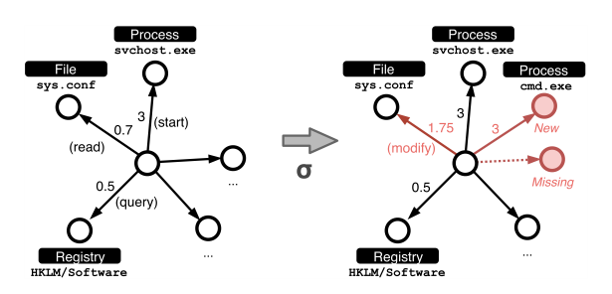
Figure - Example event representation for process svchost.exe (central node) [10]

The method for determining the minimal edit distance between two star-shaped graphs is used as the foundation for context-aware anomaly detection utilizing supervised learning on a per-process basis. The cost of required transformation operations can be used to determine the event-level deviation between instances of the same process. In order to automatically determine thresholds for each observed process, we create one or several templates from a benign environment in one of 4 different ways:

Perfect match extracts identical events found in each iteration of a process and assembles an entirely new graph

Majority mode picks the most common base graph from the input set and converts it to a template without altering its contents

Prototype extraction uses the Malheur algorithm to extract not one, but several prototypes representative of the various aspects of a single process

Similarity hashing measured document similarity using the MinHash algorithm [10].

The network operation environment represents the whole network system’s dynamic running, including the hardware, software and data resources supporting normal network services. At each time step, the network operation environment sends the real-time monitoring indicators to the anomaly detection agent as state vectors and displays the network status to the operation personnel through the network operation monitoring system. Simultaneously, the network operation environment feeds back according to key performance indicators, such as response time, throughput, and concurrency [11].
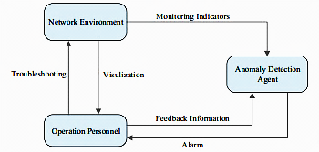
Figure - Framework of interactive anomaly detection [11]

Proposed Methodology of Research
The proposed methodology for enhancing cyber security in closed-loop network devices operating in air gapped environment involves three key capabilities:
- Autonomy: Developing autonomous agent that can independently manage and secure air gapped systems.
- Cyber-Risk Modeling: An RL agent capable to predict and detect network intrusions by analyzing the impact of cyber vulnerabilities and threats, which would enhance situational awareness and security understanding of the environment.
- Adversarial Learning: Implementing adversarial learning and game-theoretic modeling to incorporate advanced adversarial decision making and cyber deception, this would help in quantifying cyber-risk and security thereby improving the resilience and reliability of air gapped systems.
Actions in the RL framework are the possible responses the system can take when an anomaly is detected. These actions are designed to mitigate potential threats or to gather more information. Examples include:
- Alerting Administrators: Sending notifications to system administrators about potential anomalies.
- Blocking IPs: Temporarily or permanently blocking IP addresses that are suspected of malicious activity.
- Throttling Traffic: Reducing the bandwidth available to certain connections to prevent potential overloads or attacks.
- Logging for Further Analysis: Increasing the level of logging for suspicious activities to gather more data for future analysis.
Rewards provide feedback to the RL agent about the effectiveness of the actions taken. The goal is to maximize cumulative rewards over time, which encourages the agent to learn strategies that effectively manage anomalies. Reward signals can be designed as follows:
- Reduced False Positives: Positive rewards for actions that correctly identify and mitigate true anomalies without raising false alarms.
- Successful Prevention of Intrusions: High rewards for actions that prevent security breaches or data loss.
- Minimal Impact on Normal Operations: Rewards for actions that maintain system performance and user experience while addressing anomalies.
The proposed anomaly detection framework for an air-gapped network environment integrates three key components: the network operation environment, operation personnel and an anomaly detection agent. Central to this framework is the interactive guidance provided by the operation personnel to the anomaly detection agent. This human evaluation plays a crucial role, serving as a more significant and directional based reward for model convergence compared to the traditional environment reward as demonstrated in the figure:
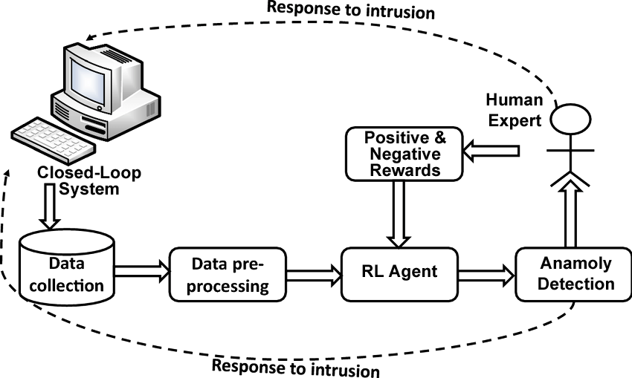
Figure - Framework for RL based Anomaly Detection System

Protocol for Data Collection
A public dataset called “Microsoft Malware Detection dataset (MMDD)” is proposed to be used for anomaly detection in our work, which include two kinds of files in the dataset: (1): .asm file and (2): .bytes file. Total train dataset consists of 200GB of data, out of which 50GB is .bytes files and 150GB is .asm files. There are a total of 10,868 .bytes files and 10,868 asm files, comprising 21,736 files in total, with nine possible class labels denoting 9 types of malwares. There are 10,868 files of asm of size around 150 GB. The initial observation of asm files shall be Address, Segments, Opcodes, Registers, function calls and API related. The number of files in each kind of class is given in Table I. [12]

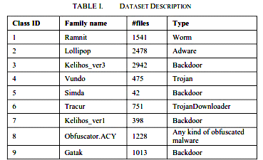

Experimental Setup
The prototype (RL agent) of the closed loop network shall be implemented in a test-bed environment consisting of few physical windows computers used on and off over the course of half a year. One additional virtual windows instance shall be utilized for dynamically monitoring malicious software and automated targeted attacks on demand. The repository of data used for evaluating the system would include individual events across all monitored processes. All the events would be recorded on the aforementioned analysis VM. For these malicious traces, we would execute APT malware samples and attack softwares through KALI linux, ranging from DarkComet and unnamed Remote Access Trojans (RATs) to various crypto-miners and tools like ShoulderSurfer. Since our system shall not be used for malware classification but considers their anomalous behavior. We would use a Common Attack Pattern Enumeration and Classification (CAPEC) based classification to describe patterns for e.g. reconfiguring the system or disabling security mechanisms.

Method of Analysis and Validation

The determination of an optimal course of RL agent action may need to be computed in a small amount of time, with limited resources. An agent may be required to respond to the actions of intelligent actors (human experts) with partial knowledge about the closed-loop system or the impact of its own actions. A suitable decision-making approach should be taken into account not only the properties of the RL agent itself, but the environment and context in which a decision must be made. It can be explained in terms of Agent Performance Evaluation (APE) methodology as:
- Cumulative Reward: Measures the total reward accumulated by the agent over time, indicating the effectiveness of its actions in achieving the desired goals.
- Convergence Rate: Evaluates how quickly the agent's learning process stabilizes to an optimal policy.
- Exploration vs. Exploitation Balance: Assesses how well the agent balances exploring new actions against exploiting known rewarding actions.
- Sample Efficiency: Examines how effectively the agent learns from a limited number of interactions with the environment.
- Robustness: Tests the agent's ability to perform well under varying environmental conditions and uncertainties.

Expected Results
The expected outcome of this research is to develop a robust and autonomous RL agent capable of effectively managing and securing air-gapped systems in closed-loop network environment. The agent is anticipated to:
- Enhance Cybersecurity: By autonomously predicting and detecting network intrusions, the agent should improve situational awareness and security understanding, thereby reducing the risk of cyber threats.
- Optimize Anomaly Response: Through the implementation of adversarial learning and game-theoretic modeling, the agent is expected to efficiently quantify cyber-risk and enhance the resilience and reliability of the systems.
- Minimize False Alarms: The reward system is designed to encourage actions that accurately identify true anomalies with minimal false positives, ensuring effective threat mitigation without disrupting normal operations.
- Improve System Performance: By maintaining system performance and user experience while addressing anomalies, the agent should ensure minimal impact on normal operations.
- Refine Detection and Response Protocols: Using the Microsoft Malware Detection dataset and the CAPEC-based classification, the agent should refine its detection and response protocols, reducing false alarms and improving the accuracy of threat detection.

Thesis Timeline

Months/ Stages | Nov 2024 | Dec. 2024 | Jan. 2025 | Feb. 2025 | Mar. 2025 | Apr. 2025 | May. 2025
Literature review | Literature review
Problem formulation |  | Problem formulation
Solving Problem |  |  | Solving Problem
Paper Submission |  |  |  | Paper Submission
More extension of problem |  |  |  |  | More extension of problem
Write up and submission of thesis |  |  |  |  |  | Write up | Submission of thesis

References

- Alexander Kott., Ryan Thomas., Martin Drašar., Markus Kont., Alex Poylisher., Benjamin Blakely., Paul Theron., Nathaniel Evans., Nandi Leslie., Rajdeep Singh., Maria Rigaki., S Jay Yang., Benoit LeBlanc., Paul Losiewicz., Sylvain Hourlier., Misty Blowers., Hugh Harney., Gregory Wehner., Alessandro Guarino., 2018. Toward Intelligent Autonomous Agents for Cyber Defense Report of the 2017 Workshop by the NATO
- Komárková, and James Rowell João Henriques., Filipe Caldeira., Tiago Cruz., Paulo Simões., 2022. An automated closed- loop framework to enforce security policies from Anomaly Detection
- Boukema Anouk., Lahaye., Rick., 2017. Advantages of Anomaly Detection Between the Controlling Unit and Process Devices
- Hireche, O., Benzaïd, C., Taleb, T., 2022. Deep data plane programming and ai for zero-trust self-driven networking in beyond 5g. Comput. Netw. 203, 108668
- Leticia Decker,. Daniel Leite,. Luca Giommi,. Daniele Bonacorsi,. 2020. Real-Time Anomaly Detection in Data Centers for Log-based Predictive Maintenance using an Evolving Fuzzy-Rule-Based Approach
- João Henriques,. Filipe Caldeira,. Tiago Cruz,. Paulo Simões,. 2020. 6 - Combining K-Means and XGBoost Models for Anomaly Detection Using Log Datasets
- Kyverno, 2022a. Visit: https://kyverno.io
- Crossguard, 2022. Visit: https://www.pulumi.com/crossguard
- Varun Chandola., Arindam Banerjee., Vipin Kumar 2007. Anomaly Detection: A Survey
- Darktrace Attack Path Modeling - Utilizing Graph Theory to derive multi-domain risk-prioritized attack paths within networks Visit: https://darktrace.com
- R. Luh., S. Schrittwieser., 2020. Advanced threat intelligence detection and classification of anomalous behavior in system processes
- DongYang., Ze Liu., Songjie Wei., 2023. Interactive Learning for Network Anomaly Monitoring and Detection with Human Guidance in the Loop

Curriculum Vitae of MS Scholar
Write down the required details very briefly as per the format given below:

Name: Taimoor Sarwar
Father’s Name: Ghulam Sarwar
Registration Number: 232806
Contact Information:
Address: MOQ D-14, Naval Complex, Sector E-8, Margalla Road Islamabad
Phone: 03337881545
E-mail(s): 232806@students.au.edu.pk
Specialization Area: Cyber Security

Coursework Details:
Sr. No. | Subject Name (Credit Hours) | Status (Passed/Continuing/Result Awaiting/Not Yet Enrolled | Grade
1 | Machine Learning | Passed | B+
2 | Research Methodology | Passed | B+
3 | Advance Artificial Intelligence | Passed | B
4 | Deep Learning | Passed | B+
5 | Ubiquitous Computing and its applications | Passed | B+
6 | Algorithm Analysis | Passed | B+
7 | Mathematics for Artificial Intelligence | Passed | B
8 | Computer vision | N/A | N/A
9 | Deep Reinforcement Learning | N/A | N/A

Undertaking

I certify that the research work titled “Anomaly Detection through Reinforcement Learning in Closed Loop Systems” is my work. The work has not been presented elsewhere for assessment in whole or in part and where the material has been used from other sources, it has been properly acknowledged/referred.

Signature of Student:
Name of Student: Taimoor Sarwar
Registration Number: 232806

